Platform 4
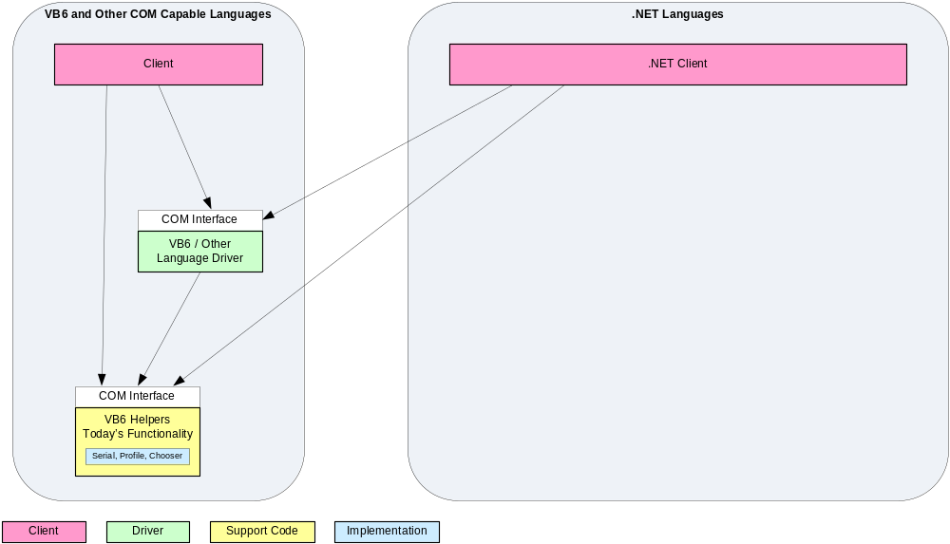

Platform 5
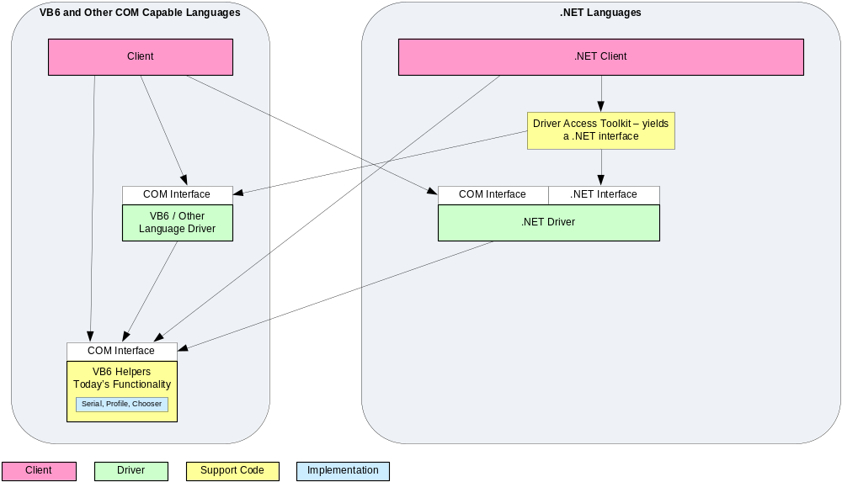

Platform 6* - Original COM Clients
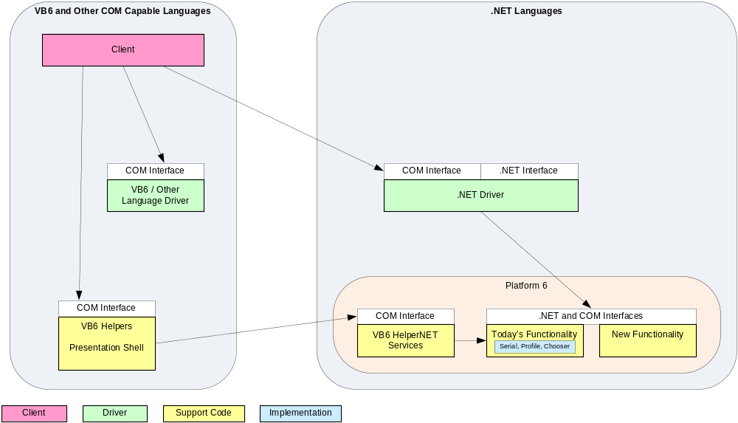
* Also Platform 5.5
Platform 6* - New COM Clients
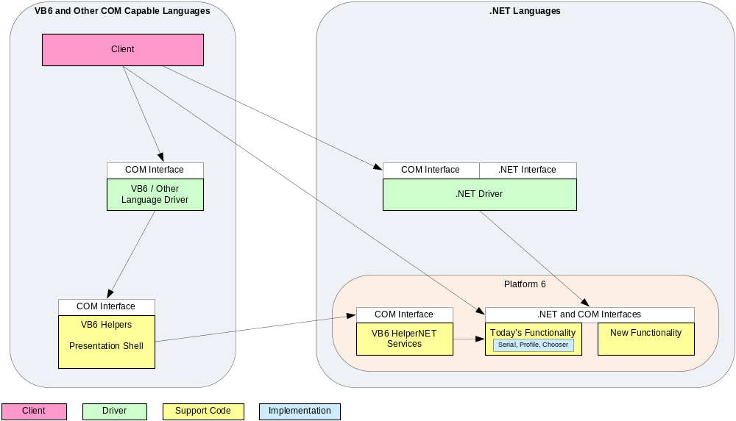
* Also Platform 5.5
* Also Platform 5.5

Platform 6* - New COM Drivers
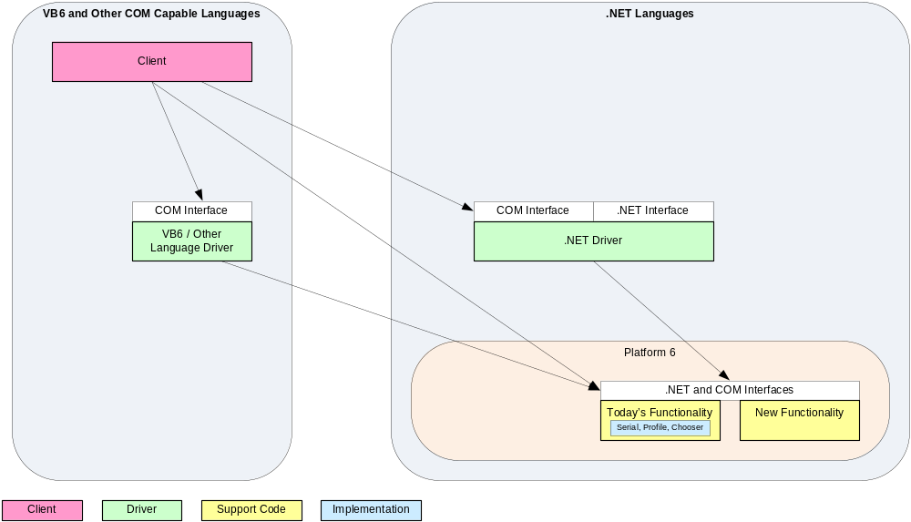
* Also Platform 5.5
* Also Platform 5.5

Platform 6* - .NET Clients (Direct)
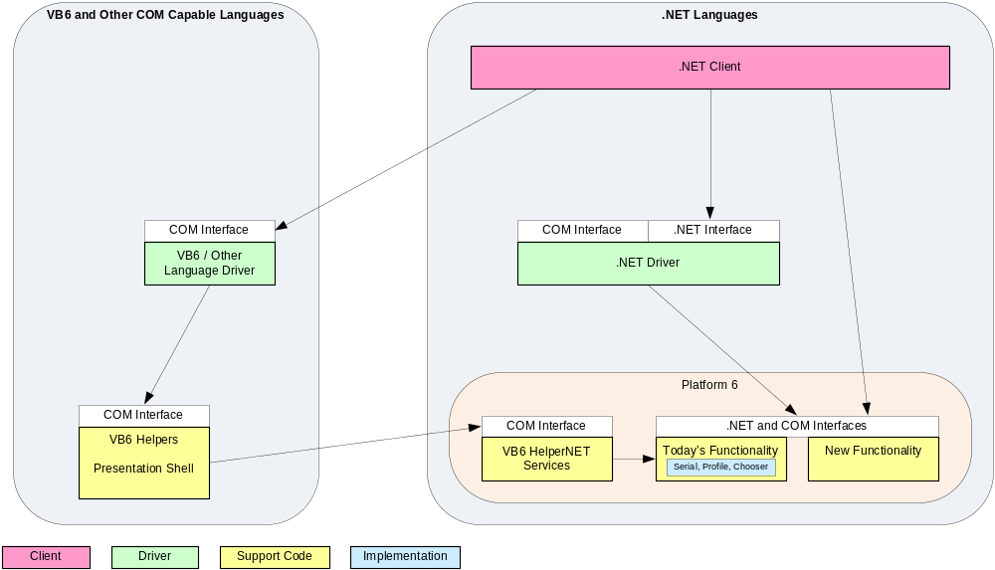
Without DriverAccess
- the .NET client sees devices as objects, i.e. not strongly typed to the device interface.
- Client has to deal with any issues arising from some drivers supporting early interfaces such as CameraV1 and some later interfaces such as CameraV2
* Also Platform 5.5
* Also Platform 5.5

Platform 6* - .NET Clients (Using DriverAccess)
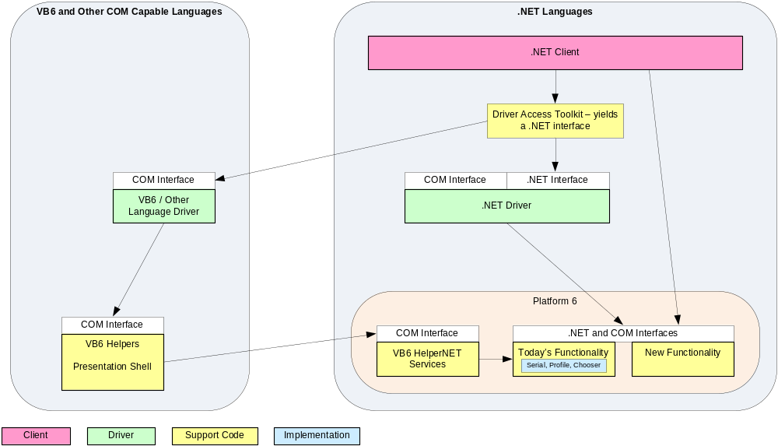
With DriverAccess
- the .NET client sees devices as strongly typed to the device interface (Intellisense shows available methods).
- Client receives a consistent Platform 6 device interface with any missing device specific members from earlier interfaces throwing NotImplemented exceptions.
* Also Platform 5.5

